March 4, 2026

MS. NAOMI M. TENECIO
State Auditor IV
Audit Team Leader
Commission on Audit
Regional Office No. XIII
Butuan City

Dear Auditor,

Greetings!

In compliance with Section 6.06 of COA Circular No.2012-001 dated June 14, 2012, we are submitting herewith a copy of Purchase Order for the procurement of goods and services delivered by PLATEFUL CATERING SERVICES for the meals during the LIKHAng Kababaihan Regional Screening on March 6, 2026 at DMW Regional Office XIII Training Hall, Butuan City, to wit:

- Purchase Order
- Notice of Award
- BAC Resolution
- Abstract of Quotations
- Request for Quotations
- Purchase Request
- Project Document
- Project Procurement Management Plan
- Annual Procurement Plan

Hope you find the attached documents in order.

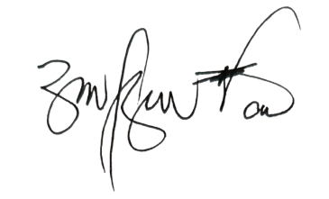
Thank you and best regards

RITCHEL M. BUTAO
Regional Director

